PHASE 3 – Create Flow And Configure Trigger
Activity 1: Create a New Flow
- Go to All menu.
- Search for Flow Designer.
- Under Process Automation, open Flow Designer.
- On the top-right corner, click New.
- Select Flow.
- Enter the following details:
  - Name: Auto Classify School IT Tickets
  - Application: Global
- Click Build Flow.
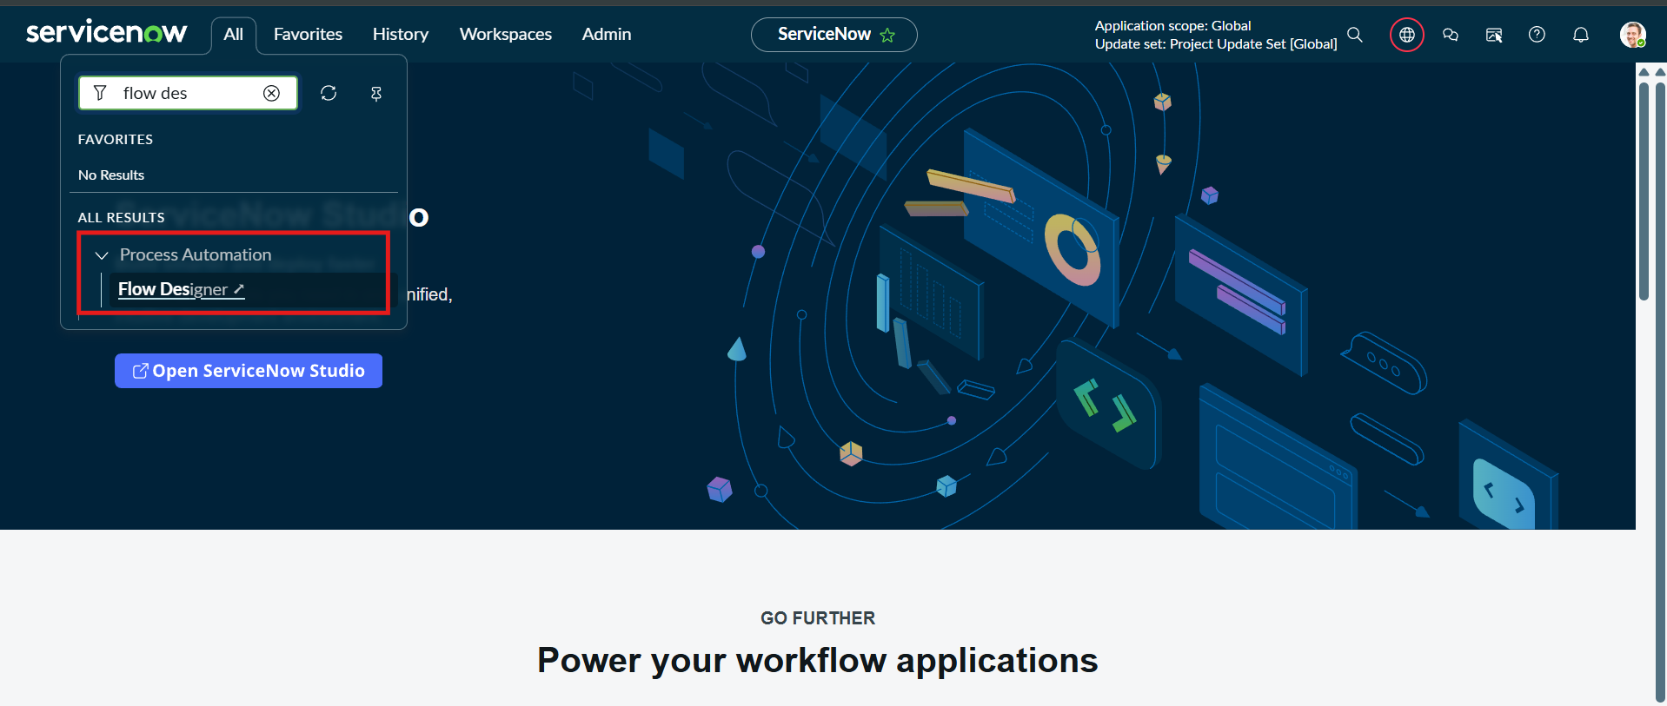
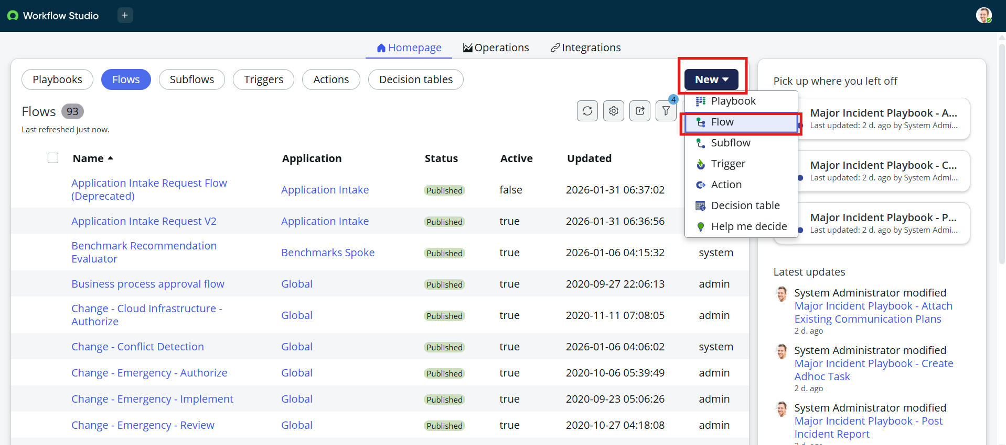
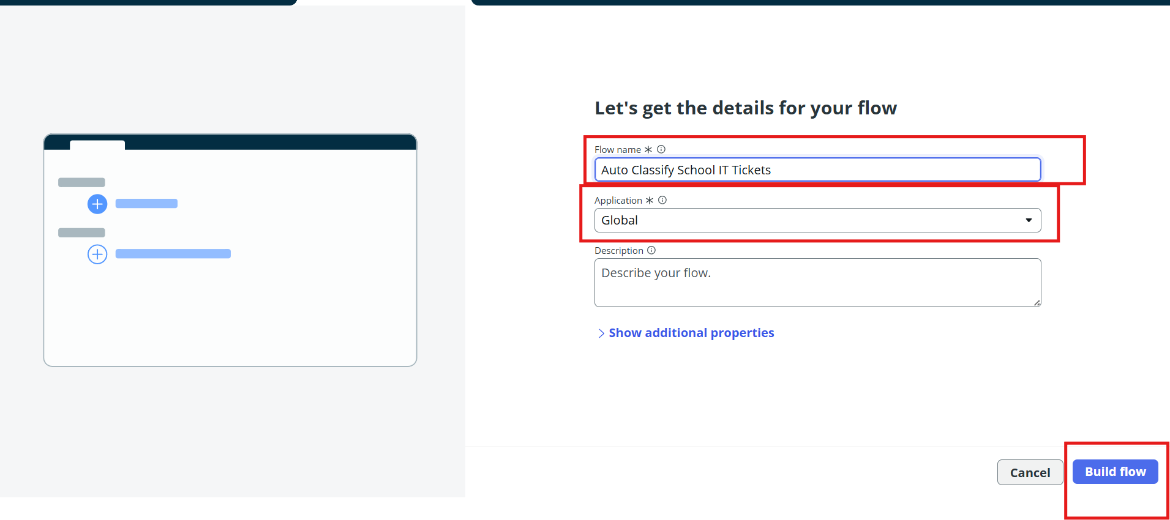

Activity 2: Configure the Trigger
- Under Trigger, select Record Created.
- Select the table:
  - Table: Incident Workflow
- Add the condition:
  - Category is Empty
- Click Done.
The flow will now automatically trigger whenever a new IT support ticket is created with an empty Category field.
